**Thevenin, Norton and Maximum Power Transfer Theorem**

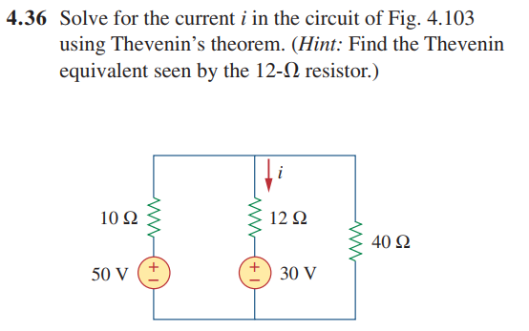

Ans: i = 500mA

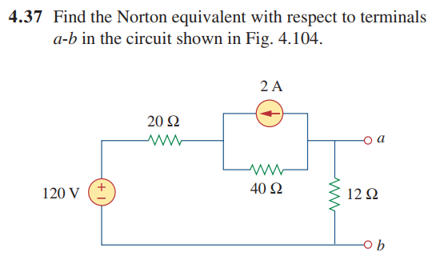

Ans: IN = 666.7 mA, RN = 10 ohm

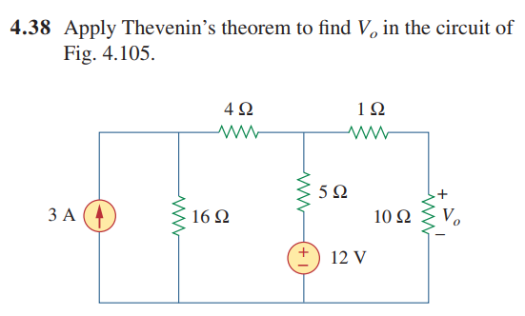

Vth = 19.2 V, Rth = 5 ohm

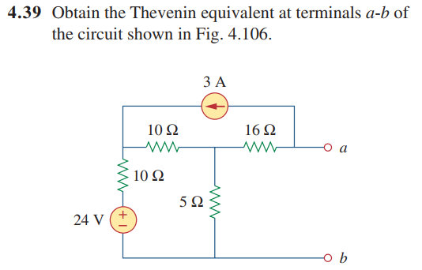

Vth = -49.2 V, Rth = 20 ohm

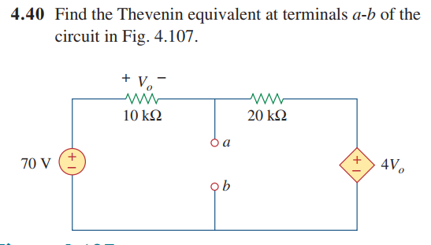

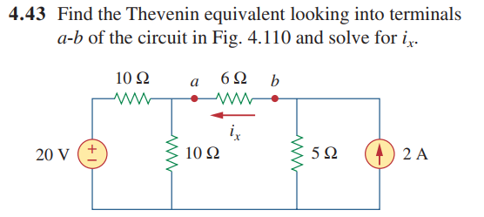

Rth = 10 ohms, Vth = 0v

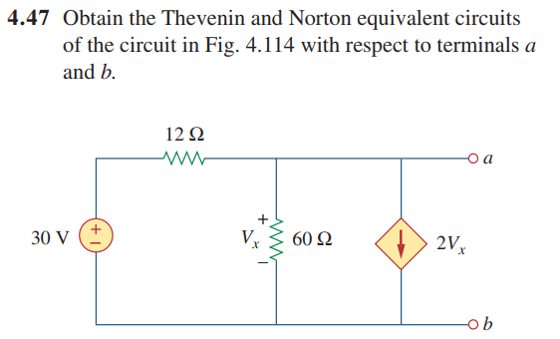

Rth = 0.4762 ohms, Vth = 1.19V